Cellular automata Scrambling

Sunil Vanmullem

Contents

Scrambler composition 4

Introduction
We introduce a scrambler that uses cellular automata to read scrambling instructions
In our previous paper we introduced the CARB notation for cellular automata, which captures the CA rules in a comprehensive and flexible notation.

Scrambling overview
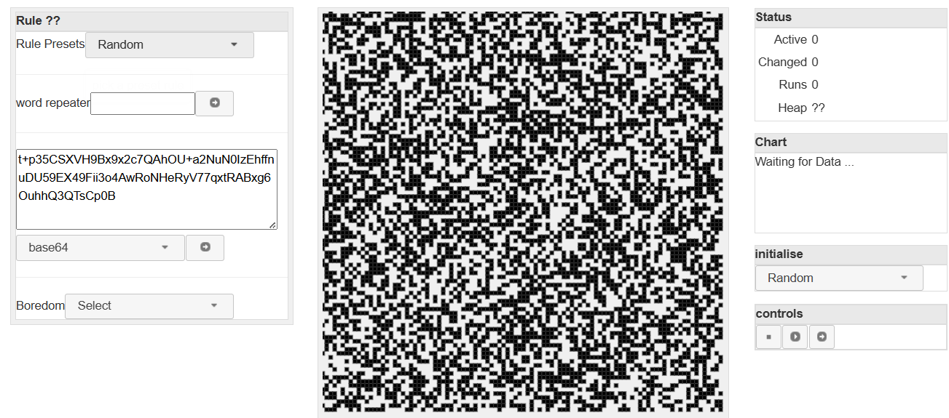
In the CA explorer, we showed the state of the cellular automata in the Grid part. That grid part can be interpreted to be a stream of deterministic but random bits, which can be read to read numbers. These numbers can then be used to identify reversible functions that can transform data held outside the CA.
Thus anyone with the scrambled data, the initial grid state and the rule being applied, can descramble the data by applying the reversible functions, but in the reverse order.

Scrambler composition
The scrambler contains the following:
- Input text
- Cellular automata - consisting of
  - CARB – the rule
  - Grid – initial state
- configuration – consisting of
  - rows and columns to organize the grid (default to the same as the CARB 100x100)
  - Initial steps – how many times to run the CA before reading data
  - The associated CARB and initial state
- Scrambler canvas (responsible for drawing the scrambled data)
  - Contains a scrambler
- Scrambled text– base64

Scrambler Events
Ready

Reversible matrix operations
All scrambler operations are reversible, so that its possible to descramble by reversing the operations.
These are
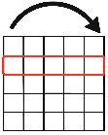 | - Line – cells move along a line
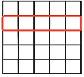 | - Translate - a row or a column
 | - Square - cells move along a predefined square
 | - Translate cell
 | - unzip row/col – alternating cells are moved in different directions
 | - reflection – a block of cells flipped across an axis
 | - transpose – swap a row with a column
 | - skew – shift all rows or columns according to their index
 | - block – apply the transforms to a defined block within the grid

